3D RNN method

In this paper, we propose a new DL framework for 3D image segmentation, based on a com- bination of a fully convolutional network (FCN) and a recurrent neural network (RNN), which are responsible for exploiting the intra-slice and inter-slice contexts, respectively. To our best knowledge, this is the first DL framework for 3D image segmentation that explicitly leverages 3D image anisotropism

A most representative RNN based scheme is Pyramid-LSTM [18], which uses six generalized long short term memory networks to exploit the 3D context.

In common practice, a 3D biomedical image is often represented as a sequence of 2D slices (called a z-stack). Recurrent neural networks, especially LSTM [8], are an effective model to process sequential data [14, 17]. Inspired by these facts, we propose a new framework combining two DL components: a fully convolutional network (FCN) to extract intra-slice contexts, and a recurrent neural network (RNN) to extract inter-slice contexts. Our framework is based on the following ideas.

There are mainly three issues to the known DL-based 3D segmentation methods. First, simply linking 2D segmentations into 3D cannot leverage the spatial correlation along the z-direction. Second, incorporating 3D convolutions may incur extremely high computation costs (e.g., high memory consumption and long training time [10]). Third, both 3D convolution and other circumventive solutions (to reduce intensive computation of 3D convolution), like tri-planar schemes or Pyramid- LSTM, perform 2D convolutions with isotropic kernel on anisotropic 3D images. This could be problematic, especially for images with substantially lower resolution in depth (the z-axis)

Stage1 : FCN (kU-Net)

There are two critical mechanisms in kU-Net to simulate such human behaviors. (1) kU-Net employs a sequence of submodule FCNs to extract information at different scales sequentially (from the coarsest scale to the finest scale). (2) The information extracted by the submodule FCN responsible for a coarser scale will be propagated to the subsequent submodule FCN to assist the feature extraction in a finer scale.

The RNN Component: BDC-LSTM

LSTM was deigned to deal with the problem of exploding/vanishing gradiant.

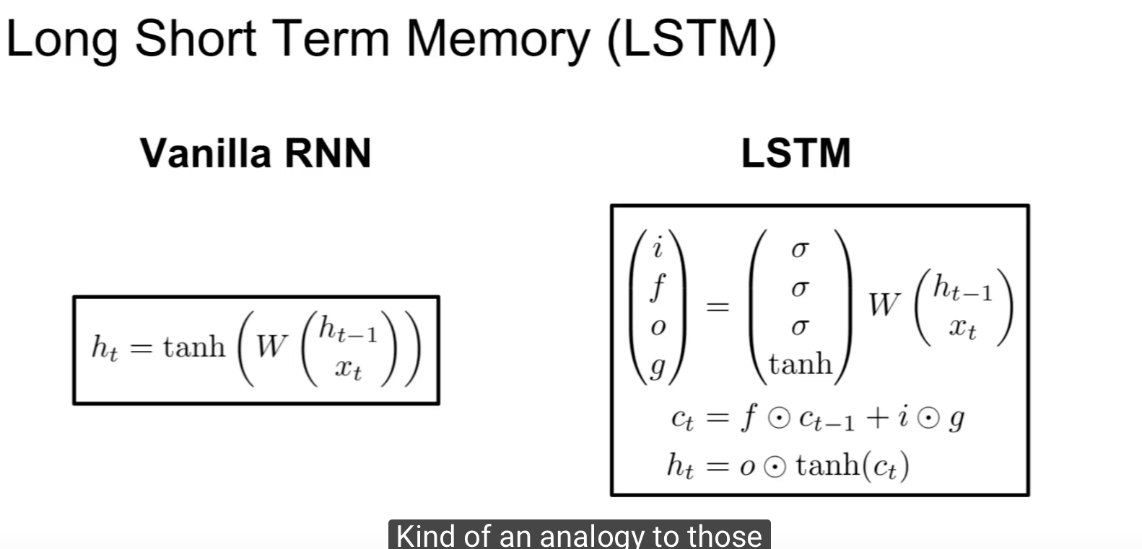

contain two hidden states: Ht and Ct (cell hidden state).



calculation:

concatonaed the current state Xt­ and the hidden state ht and multiple by large wight matrix X. from this matrix multiplication we will calculate four gates.